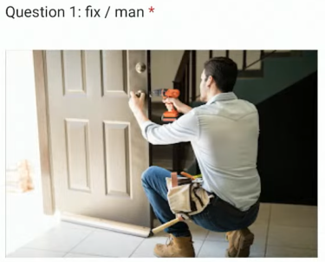

Answer: The man is fixing the door.

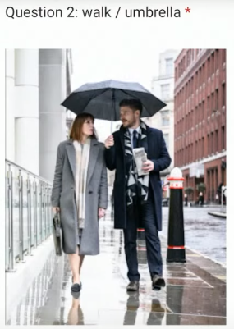

Answer: The man and the woman are walking on the street with the umbrella.

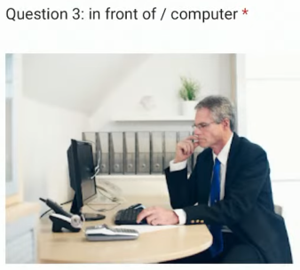

Answer: The man is sitting in front of the computer.

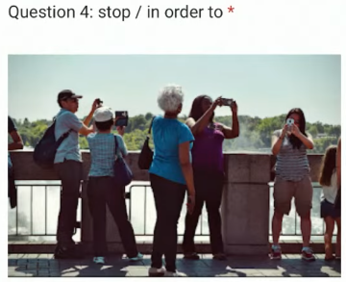

Answer: Some people are stopping on the bridge in order to take photos.

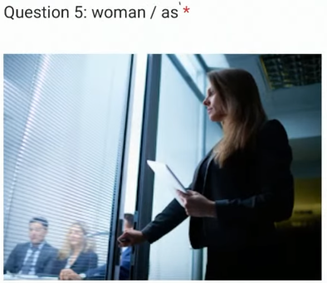

Answer: A woman opened the door as some people were discussing.

As = When: khi nào.

* As a woman entered a room, people stopped talking.

As = Because / Since

* A woman was late, as she was distubed the traffic.

As : như là

Đề 2:

* Q1:

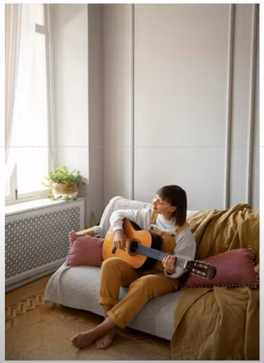

+ play/guitar

A woman is playing the guitar on a sofa.

* Q2:



+ picnic / park.

Three women are having a picnic in the park.

* Q3:

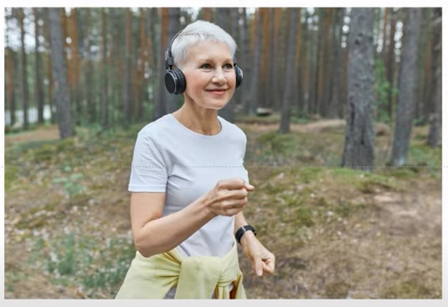

+ music / while

Công thức của while:

+ S1 + V1 + while + S2 + V2 (Nếu S1 và S2 khác chủ ngữ)

+ S + V1 + while + V2-ing (Nếu S1 và S2 khác chủ ngữ)

A woman is listening to music while jogging in the jungle/park.

* Q4:



+ fill/with

A man is filling his car with gasoline.

To fill one’s car(his car – her car - …) with gasoline/gas/petrol.

* Q5:

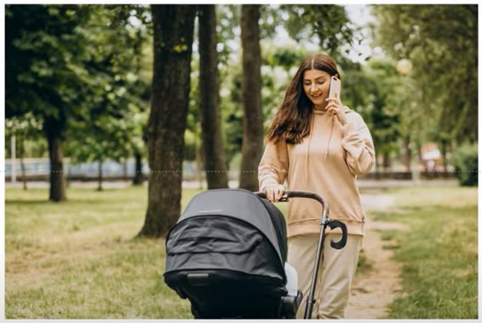

+ woman / stroller

A woman is pushing a baby stroller while having a phone call.

A woman is pushing a baby stroller while calling a phone.

To push a baby stroller

To have/make a phone call

Đề 3:

* Q1:

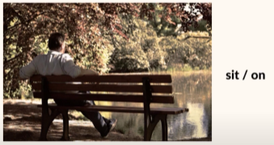

A man is sitting on the bench near the lake.

* Q2:

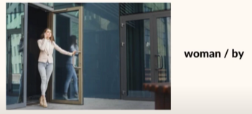

A door is being opened by a woman.

* Q3:

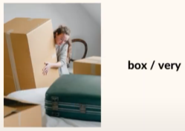

A woman is carrying a box and it’s very heavy.

* Q4:

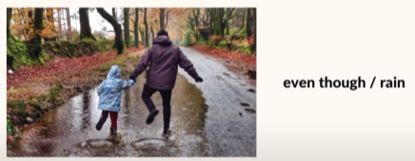

Even though it rains, 2 people are walking in the park.

* Q5:

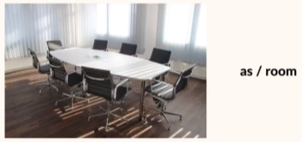

A room doesn’t have any people as there are not any meeting.

Đề 4:

* Q1:



A man is paying for a delivery man with his credit card.

* Q2:

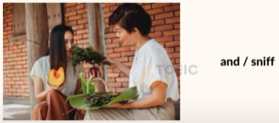

There are two women and one of them is sniffing the vegetables.

* Q3:



A man is sitting in front of the computer in the working office.

* Q4:

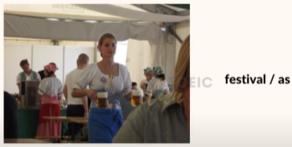

As the beer festival, people are drinking beers.

* Q5:

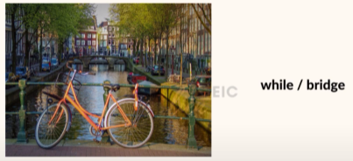

A bicycle is leaning against the bridge while there are no one here.

Đề 5:



A woman is looking at a laptop in the coffee shop.

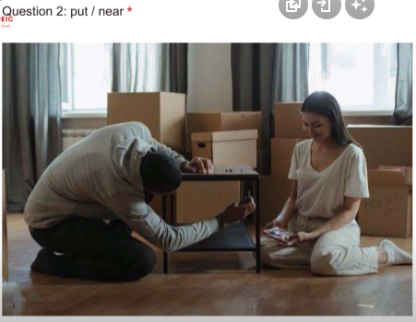

A man is putting something under the table near a woman.

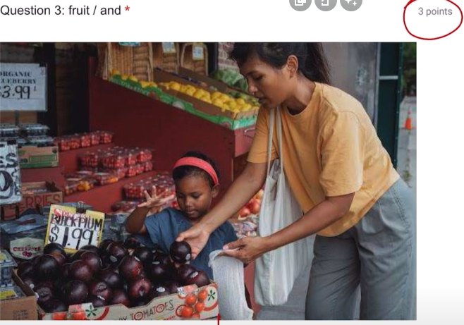

A woman and her daughter are buying some fruits.

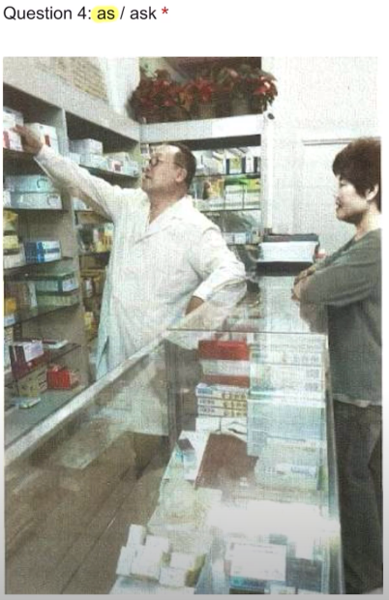

A doctor is taking something as a woman asks him to do.

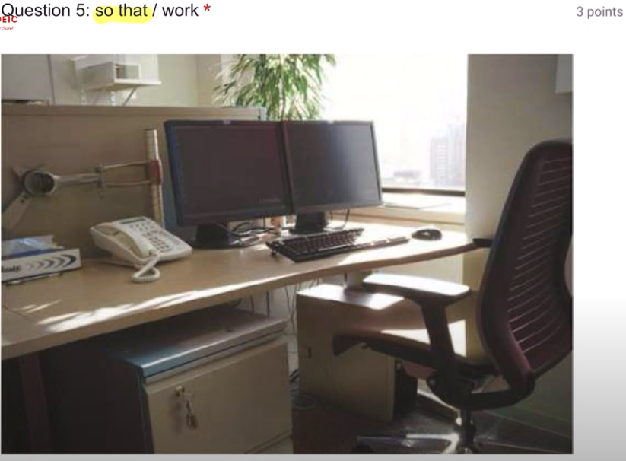

Because today is Sunday so that there are not any people work.